Solar Irradiance History Bulk
Purchase Instructions & Site Coordinates
OpenWeather Marketplace | TCEQ Regions 13–16 | 2015–2025
PURCHASE SUMMARY
Product | Solar Irradiance History Bulk
Purchase Link | home.openweathermap.org/solar_irradiance_history_bulks/new
Total Sites | 15
Est. Cost per Site | ~$32
Est. Total Cost | ~$480
Budget | $500 (remaining ~$20)

1. OpenWeather Form Settings
Configure the following settings on the order form. These match the dropdown and date fields visible on the purchase page:
ORDER FORM CONFIGURATION
Date Range (Start) | 01-01-2015
Date Range (End) | 31-12-2025
Solar Parameters | All
Time Interval | 1 h
File Format | CSV, JSON
Download | File per location
Location Entry | Import → Upload solar_irradiance_sites.csv

Table 1. Exact settings for the OpenWeather Solar Irradiance History Bulk order form.
“Solar parameters: All” ensures GHI (Global Horizontal Irradiance), DNI (Direct Normal Irradiance), and DHI (Diffuse Horizontal Irradiance) are all included for both clear-sky and cloudy-sky models. “File per location” generates one downloadable file per site, simplifying integration with the R analysis pipeline.

2. Coverage Summary
Fifteen air quality monitoring sites were selected across all 13 counties and 4 TCEQ regions with active monitoring in southern Texas. The selection maximizes geospatial coverage while staying within a $500 budget.
- County coverage: 13 of 13 monitored counties covered (100%)
- Regional coverage: All 4 TCEQ regions represented (R13: 7 sites, R14: 3 sites, R15: 3 sites, R16: 2 sites)
- Spatial buffer: A 40 km buffer around selected sites encompasses all 44 AQ monitoring sites; 89% within 20 km

2.1 Selection Rationale
Sites were chosen using a two-tier strategy. Tier 1 (13 sites) places one anchor in each county, prioritizing sites with the broadest pollutant monitoring suite. Tier 2 (2 sites) adds spatial infill in Bexar County (~60 km metro span) and Cameron County (~60 km N–S extent).

2.2 Pollutant Priority Scoring
Each site was scored based on the health relevance of its monitored pollutants to the BREATHE-CC Study. Higher-scoring sites yield greater analytical return on the irradiance investment:
Pollutant | Weight | Rationale
PM2.5 | 5 | Primary respiratory health endpoint
PM10 | 4 | Coarse particulate matter
SO2 | 4 | Industrial criteria pollutant
Ozone (O3) | 4 | Photochemical oxidant
NO2 / NOx | 3 | Traffic-related pollution marker
CO | 2 | Combustion indicator
VOCs | 3 | Volatile organic compounds
Table 2. Pollutant priority weights. A site’s total score = sum of weights for all monitored pollutants.

3. Site Coordinates for Purchase
The table below lists all 15 sites in priority order. The “CSV Location Name” column shows the exact string used in the import file. The “✓” column is for checking off sites as they appear on the map after import.
# | Tier | Rgn | County | Pollutants | Scr | Lat | Lon | ✓ | CSV Location Name
1 | T1 | R13 | Bexar | NO2, NOx, O3, PM2.5, SO2 | 19 | 29.2754 | -98.3117 |  | Calaveras Lake - Bexar
2 | T2 | R13 | Bexar | NO2, NOx, O3, PM2.5 | 15 | 29.5151 | -98.6202 |  | SA Northwest - Bexar
3 | T1 | R15 | Hidalgo | O3, PM10, PM2.5 | 13 | 26.2263 | -98.2909 |  | Hidalgo 0043 - Hidalgo
4 | T1 | R16 | Webb | CO, O3, PM10 | 10 | 27.5079 | -99.5239 |  | Webb 0016 - Webb
5 | T1 | R14 | Nueces | PM2.5, SO2 | 9 | 27.8045 | -97.4316 |  | Nueces 0032 - Nueces
6 | T1 | R15 | Cameron | O3, PM2.5 | 9 | 25.8925 | -97.4938 |  | Cameron 0006 - Cameron
7 | T1 | R13 | Comal | O3, NOx | 7 | 29.7608 | -98.4628 |  | Bulverde Elem - Comal
8 | T1 | R13 | Guadalupe | O3, NOx | 7 | 29.5886 | -97.9322 |  | Seguin Outdoor LC - Guadalupe
9 | T1 | R13 | Karnes | NO2, NOx | 6 | 28.8804 | -97.8881 |  | Karnes 1070 - Karnes
10 | T1 | R13 | Wilson | NO2, NOx | 6 | 29.1307 | -98.1481 |  | Wilson 1038 - Wilson
11 | T1 | R13 | Atascosa | PM2.5 | 5 | 29.1630 | -98.5892 |  | Von Ormy Hwy 16 - Atascosa
12 | T1 | R14 | Kleberg | PM2.5 | 5 | 27.4224 | -97.3009 |  | Kleberg 0314 - Kleberg
13 | T1 | R16 | Maverick | PM2.5 | 5 | 28.7046 | -100.4512 |  | Maverick 0004 - Maverick
14 | T1 | R14 | Victoria | O3 | 4 | 28.8362 | -97.0055 |  | Victoria 0003 - Victoria
15 | T2 | R15 | Cameron | O3 | 4 | 26.2003 | -97.7127 |  | Cameron 1023 - Cameron
Table 3. All 15 purchase sites with coordinates and CSV location identifiers.

4. CSV Import Instructions
The accompanying file solar_irradiance_sites.csv is pre-formatted for direct upload. Key formatting requirements from OpenWeather:
- Delimiter: Semicolon delimiter (;) — not comma
- Encoding: UTF-8 encoding
- Column order: location (string); latitude (float); longitude (float)
- Precision: Coordinates are rounded to the 6th decimal place by OpenWeather
- Header: No header row — data starts on line 1
CSV File Contents
Calaveras Lake - Bexar;29.2754;-98.3117 SA Northwest - Bexar;29.5151;-98.6202 Hidalgo 0043 - Hidalgo;26.2263;-98.2909 Webb 0016 - Webb;27.5079;-99.5239 Nueces 0032 - Nueces;27.8045;-97.4316 Cameron 0006 - Cameron;25.8925;-97.4938 Bulverde Elem - Comal;29.7608;-98.4628 Seguin Outdoor LC - Guadalupe;29.5886;-97.9322 Karnes 1070 - Karnes;28.8804;-97.8881 Wilson 1038 - Wilson;29.1307;-98.1481 Von Ormy Hwy 16 - Atascosa;29.1630;-98.5892 Kleberg 0314 - Kleberg;27.4224;-97.3009 Maverick 0004 - Maverick;28.7046;-100.4512 Victoria 0003 - Victoria;28.8362;-97.0055 Cameron 1023 - Cameron;26.2003;-97.7127
Contents of solar_irradiance_sites.csv (semicolon-delimited, no header row).

5. Step-by-Step Purchase Procedure
- Step 1 — Open order form. Navigate to the purchase page:
https://home.openweathermap.org/solar_irradiance_history_bulks/new
- Step 2 — Import locations. Click the “Import” tab (third tab after “By location” and “By coordinates”). Click “Import CSV file” and upload solar_irradiance_sites.csv. Verify that 15 numbered pins appear on the map with the correct location names.
- Step 3 — Set date range. Set start date to 01-01-2015 and end date to 31-12-2025 using the date picker (clock icon).
- Step 4 — Solar parameters. Set the Solar parameters dropdown to “All” (includes GHI, DNI, DHI for clear sky and cloudy sky).
- Step 5 — Time interval. Set the Time interval dropdown to “1 h”.
- Step 6 — File format. Set File Format to “CSV, JSON” (provides both formats for flexibility).
- Step 7 — Download mode. Set Download to “File per location” (one file per site for clean pipeline integration).
- Step 8 — Review & checkout. Review order. Verify total is approximately $480. Click “Place Order” and proceed to checkout.
- Step 9 — Download data. Download link arrives via email. Also available under “Orders” in your OpenWeather account.

Note: If pricing has changed and the budget cannot cover all 15 sites, drop Tier 2 sites first (SA Northwest and Cameron 1023) to preserve the 13 county-anchor sites.

6. Expected Cost Breakdown
Item | Qty | Cost
Solar Irradiance History Bulk per site | 15 | ~$32/site
Subtotal | 15 sites | ~$480
Available budget |  | $500
Remaining after purchase |  | ~$20
Table 4. Estimated cost breakdown.

7. Site Selection Map
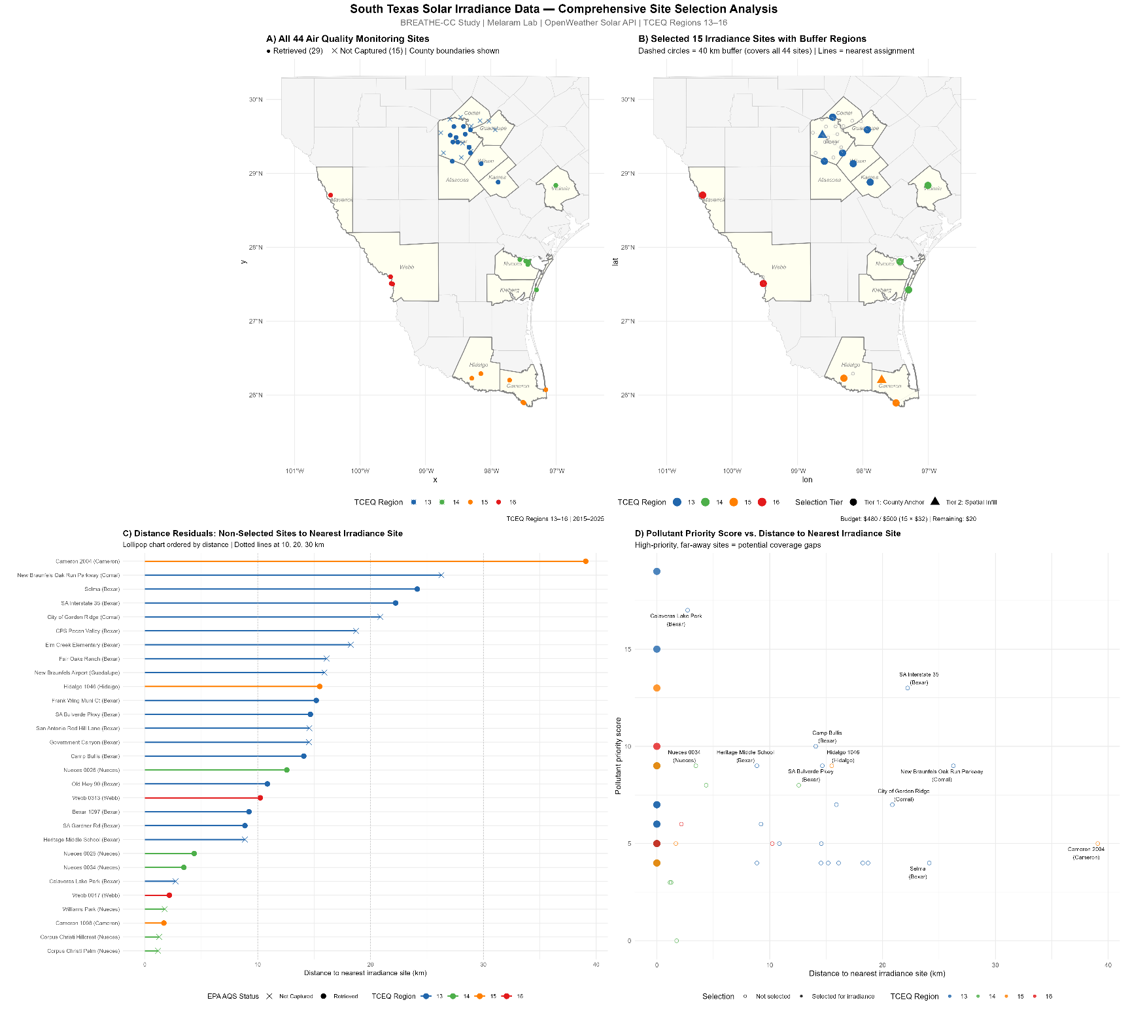
Insert the map figure generated from the R script (solar_irradiance_comprehensive_analysis.R) below.

Figure 1. Comprehensive site selection analysis — insert from R output.

